|  |  |  |  |  |
| --- | --- | --- | --- | --- |
|  | **Criteria** | **Grade claimed** | **Supporting arguments** | **Supporting evidence (refer to appendix if needed)** |
| **Basic** | Professional Behaviour | D | As team leader it was my duty to conduct work in as professional manner as possible. I had to communicate in a professional manner towards the dev and design teams, with the product owner, and to the academic supervisor. All teams and stakeholders were pleased about how professional and committed I was to the project. | Conversation threads between myself and the product owner.  Meetings conducted with academic supervisor (Yong)  Weekly Recordings with team, please let me know if you require the downloads. |
| D | Overseeing the productivity and functionality of the team, I updated, assigned, and created cards in the trello board. As such, this was a way of conducting project management in a professional software. In cards you can find me communicating with peers so that we can create a professional product. | Trello board professional discussion to other members of the team. |
| Accountability (Worklogs) | D | Currently I have added up to 127 hours’ worth of work commitment to the project. As such, I am adhering to the expected 10 hours per week and am expected to hit 150 hours of work. | [Worklog for James Papas: Click Here](https://deakin365.sharepoint.com/:x:/r/sites/DeakinCloudVentures/Shared%20Documents/Escape%20Room%20Games%20-%20The%20Island/Trimester%201%202021%20-%20Work/Worklog%202021%20T1.xlsx?d=wdb4a73bb88274b229939e8a593b1ea2b&csf=1&web=1&e=HUl6p0) |
| Attendance | D | I have attended every team, product owner, and academic supervisor meeting. As such, I am adhering to the above 90 percent attendance log. | [Attendance Log for The Island Team](https://deakin365.sharepoint.com/:x:/r/sites/DeakinCloudVentures/Shared%20Documents/Escape%20Room%20Games%20-%20The%20Island/Trimester%201%202021%20-%20Work/Group%20Attendance%20Log%202021.xlsx?d=wdcf04d66d50e4cbca4c9a882c6e2388d&csf=1&web=1&e=Roh7XO) |
| Engagement | D | I have excelled at engaging and committing to the project as I have contributed to most tasks one way or another. All tasks were created by me and assigned to members accordingly. As such, members were coming to me for further task clarification, and therefore I was actively participating in achieving finished tasks. Furthermore, I made hundreds of commits to the project, ultimately showing how engaged I was in finishing the app. | Please refer off engagement screenshot in the Sourcetree window.  You can also find all the tasks I was assigned to that I assisted in completing. [Trello Link](https://trello.com/b/gNlzJ7ax/escape-room-game-the-island-trello) |
| **Core** | Communication | HD | I excelled in providing clear and concise communication to the team and all stakeholders. I was able to clearly explain all project deliverables in meetings and was also writing and communicating everything down for the team. As such, this ultimately influenced a more efficient and effective work environment to stay more productive. | Trello Board communication between myself and the team.  Microsoft Teams Communication between myself and the team. |
| Teamwork | HD | With communication came teamwork. On many occasions, members of the team needed tasks clarified or also needed overall help. I was always happy to provide this to the team. Using Teams and Trello as the main discussion tools between the team, it was rather easy to work as a team to attain the same goals together. We were able to commit work without risking merge conflicts between members. | Please refer off Microsoft Teams and [trello board](https://trello.com/b/gNlzJ7ax/escape-room-game-the-island-trello) screenshots to capture the teams effective teamwork in completing trello tasks. |
| Process | D | I was able to contribute to the project using the required processes and procedures required of the unit. As such, I was able to commit my work to the correct branches whilst also notifying the team when I was to commit so we did not impede on each other’s work. | Please refer off the Microsoft Teams commit discussion.  Please refer off the Sourcetree attachment below |
| Product | HD | I provided exceptional and sustained contributions to the project. In this iteration, I achieved a highly challenging task of importing all the new attackers into the game whilst also animating the in-game characters. It seemed highly unlikely, however I managed to import the characters and animations at a very high exceptional standard. All these commits were provided with quality work as well as on a consistent basis. | Please refer to the squad demo slides for my completed tasks over this iteration and how they look on devices. |
| D | As a team leader, I drove and contributed to team discussion and meetings. I continuously ensured that tasks were clearly explained and that all stakeholders were aware of what needed to be done to further improve the app. As such with my commitment to the team we have been able to produce high quality work. | Please find all recordings in Microsoft Teams for proof. Additionally, please find all meetings with academic supervisor in meetings too.  [Squad Demo 2](https://deakin365.sharepoint.com/:p:/r/sites/DeakinCloudVentures/Shared%20Documents/Escape%20Room%20Games%20-%20The%20Island/Trimester%201%202021%20-%20Work/Iteration%20Presentations/Iteration%202.pptx?d=w7d02d4d6efc64cafb2d5526cc126ec5d&csf=1&web=1&e=KzWxLU) |
| IT Skills | HD | I demonstrated outstanding skill and knowledge relevant to my area of IT discipline. I used my discipline and expertise to better animate the game and to provide a seamless UI that all users can enjoy. The UI is fitted with ambient music and visual themes that are captured from island scenes. | Please refer off my completed work in the appendices section. |
| **Advanced** | Self-Awareness | HD | I was aware of what my strengths and weaknesses were when completing this project. As such, I oversaw the direction of the project as well as the design part of it. As I have prior design strengths, I utilised that strength to create work of an IT professional. | Please refer off my completed work in the appendices section. |
| Project Management | HD | As project manager, and team leader, I updated the trello board and the team members of the progress of project and how we are doing in terms of projected targets. As such, with this constant managing we all surpassed all outcome expectations and the product owner was greatly impressed. No we have a finished product that works perfectly. | Please refer to the trello board for my effective and structure management. |
| Mentoring | HD | I worked heavily with Andrew S and Sean so we can complete the final important tasks before offloading the project. This meant that I worked with Andrew so I could teach him a bit about management of the project and the design part of it. Therefore, we had many catch ups whereby I mentored him to be a future team lead of the project. | This was mostly conducting in discord which has no recording software. |

Basic: State facts and provide evidence

Core: Use the STAR Model

* **Situation:** describe a work situation that you were faced with
* **Task:** describe the task that you had to complete
* **Action:** describe the action that you took to complete the task
* **Result:** describe the result of your action

Advanced: Use a reflection framework

* **Situation facts:** describe a work situation that you were faced with
* **Situation thoughts:** describe your thoughts on the situation and you goal
* **Action plan**: describe the plan you will action to achieve your goal
* **Result:** describe the result of your actions or ongoing plan

*As this was our final iteration, there will be no further tasks committed by us seniors however provided are a few suggestions for the next juniors to develop in the future. I would suggest that the next juniors further improve the game by fixing remaining bugs in the attacks, adding dying animations to animals, adding textures to the snake, and creating a new attacker tracking system for the snake as well. Furthermore, I would suggest implementing a new multiplayer system to the game and a new cave the user can hide in to get some health back up. Overall, the project was very fun and challenging but it was a pleasure to manage to a completed phase.*

# Appendices (if any)

**Conversation Thread to product owner:**

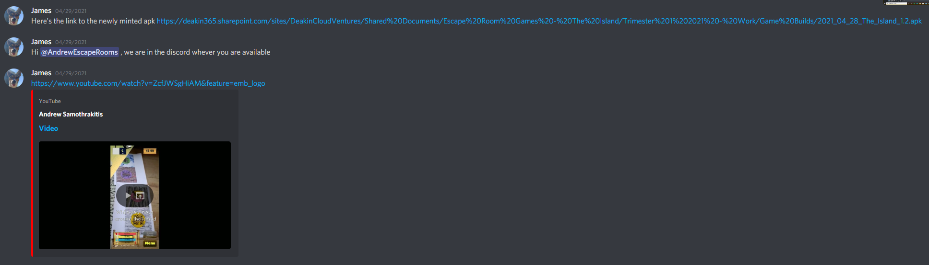

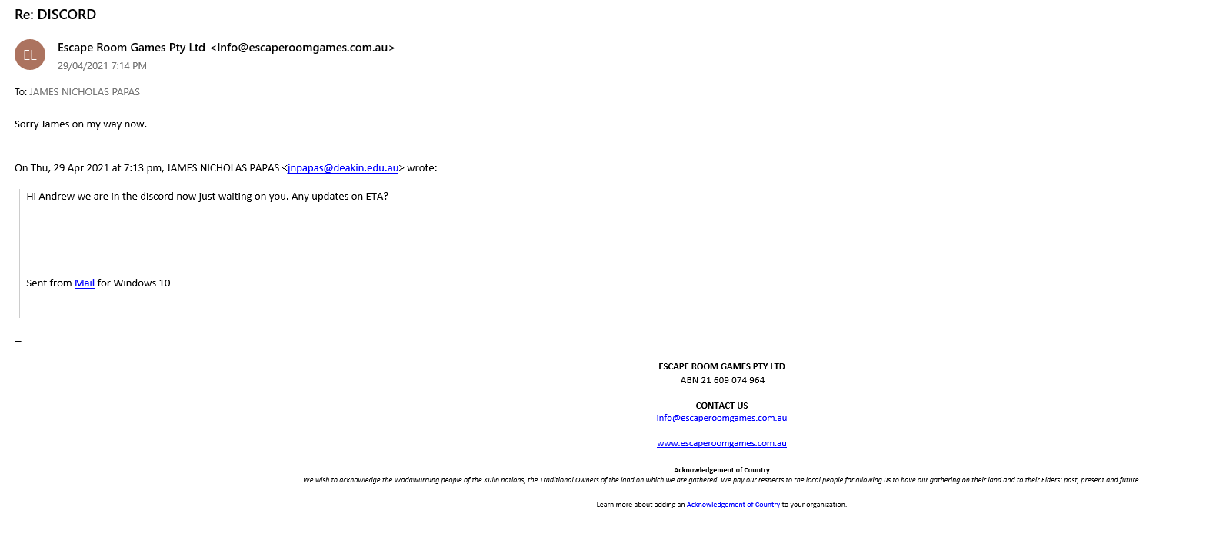

**Communication and professionalism between myself and the teammates:**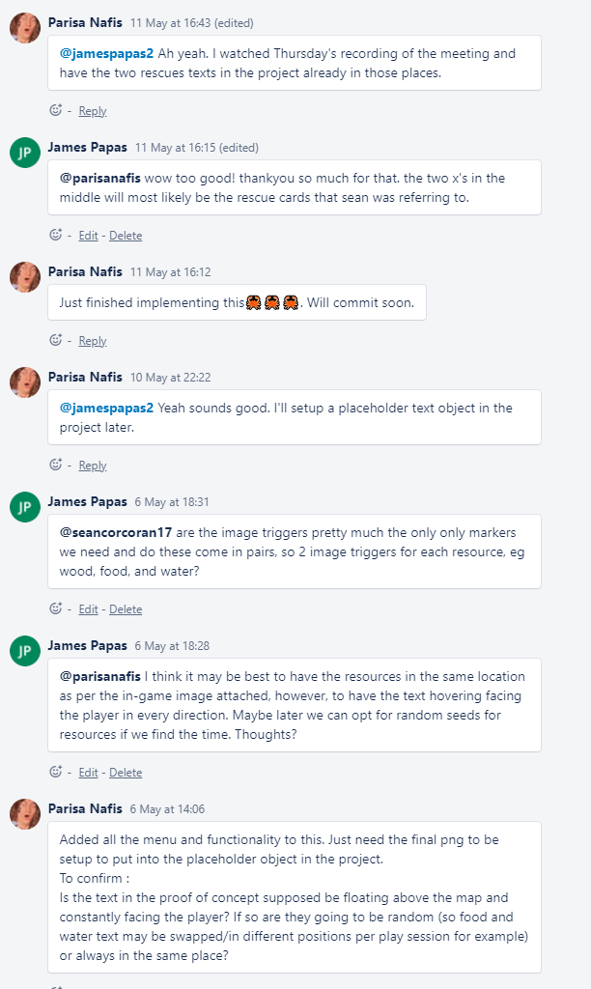

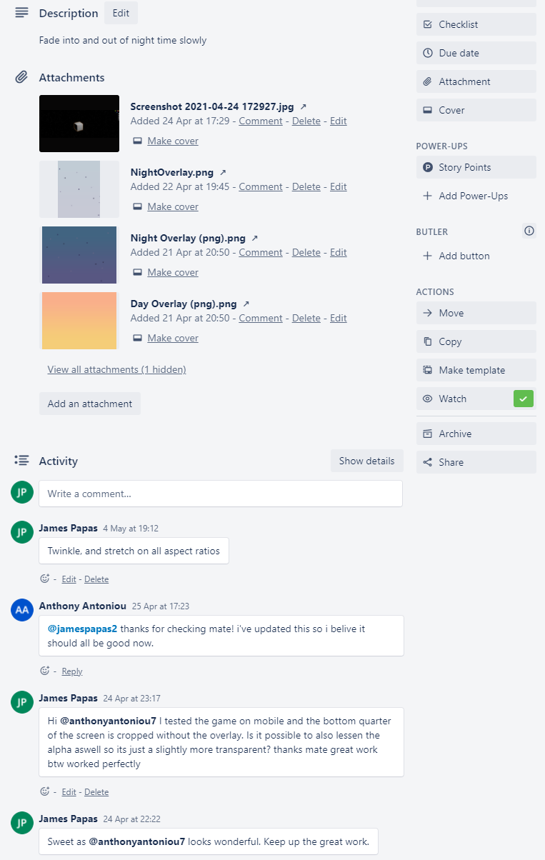

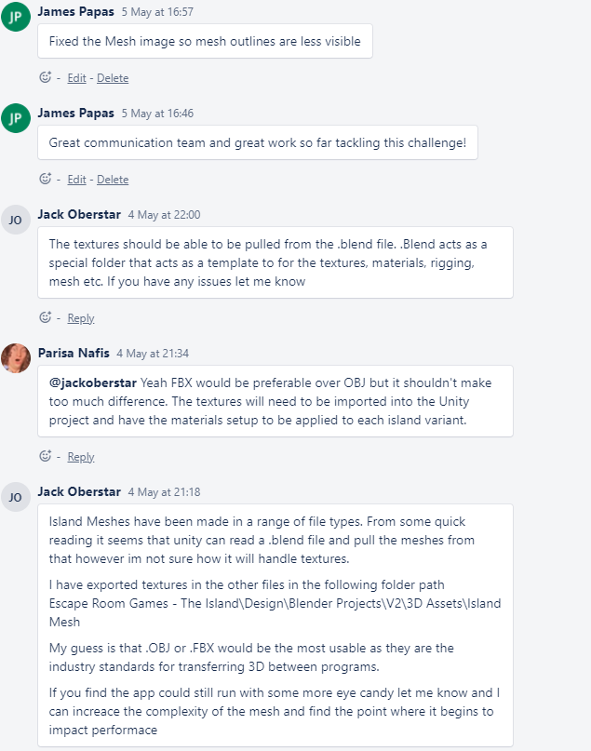

**Worklog of Hours:**

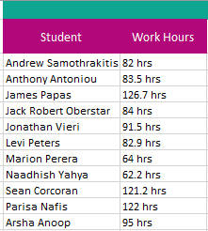

**Attendance Log:**

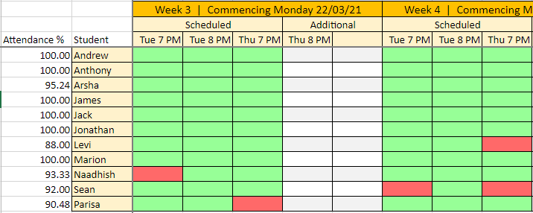

**Engagement and commitment to the project:**

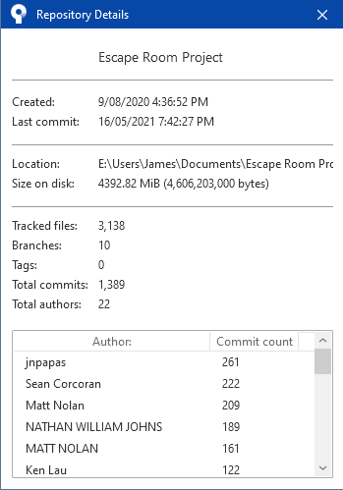

**Trello Board Screenshot of tasks assigned to and completed or in completion:**

<https://trello.com/b/gNlzJ7ax/escape-room-game-the-island-trello>

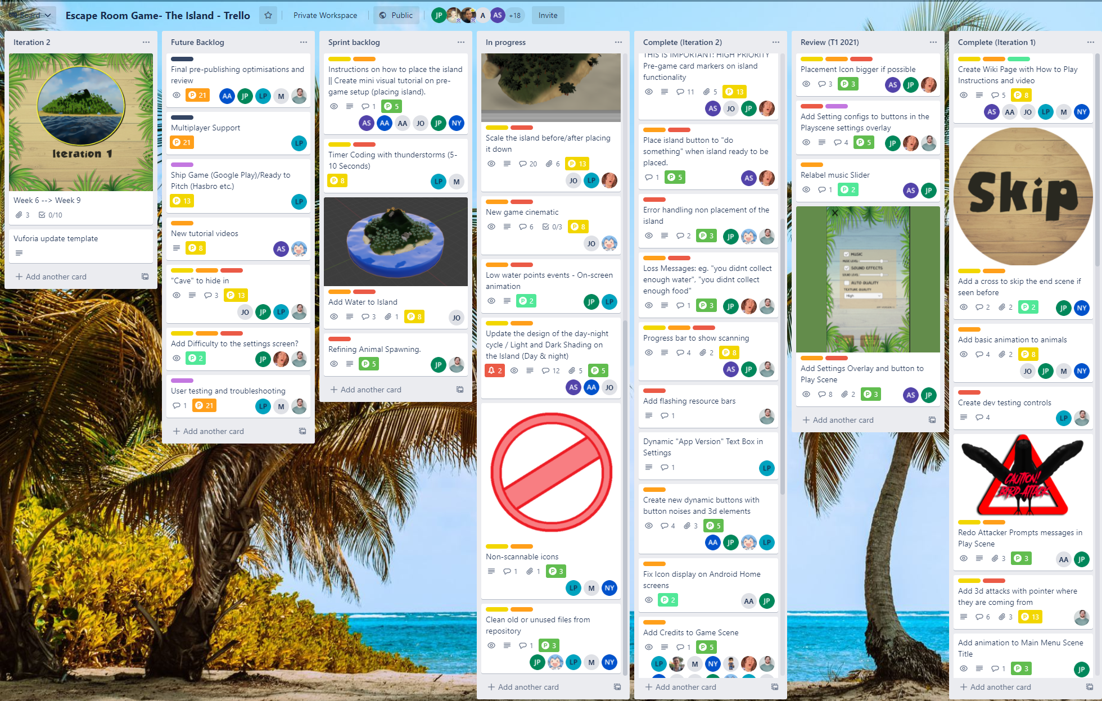

**Microsoft Teams Communications:**

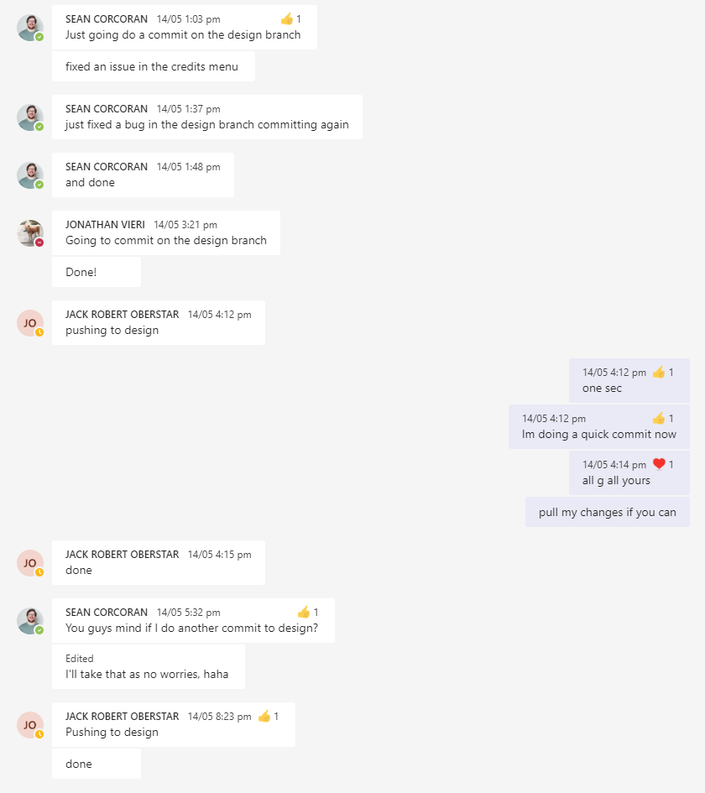

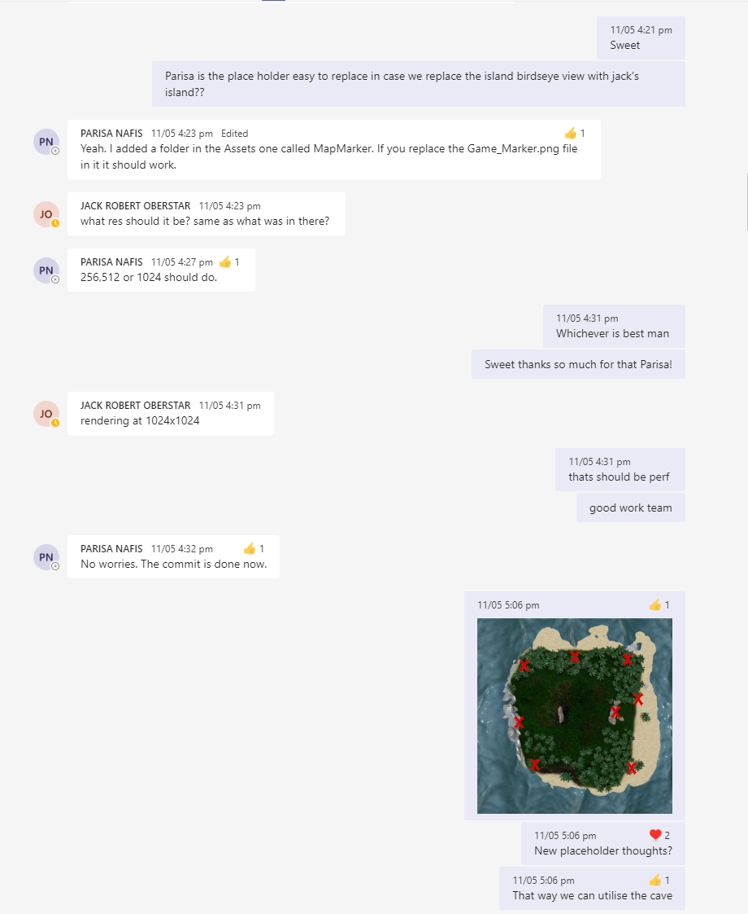

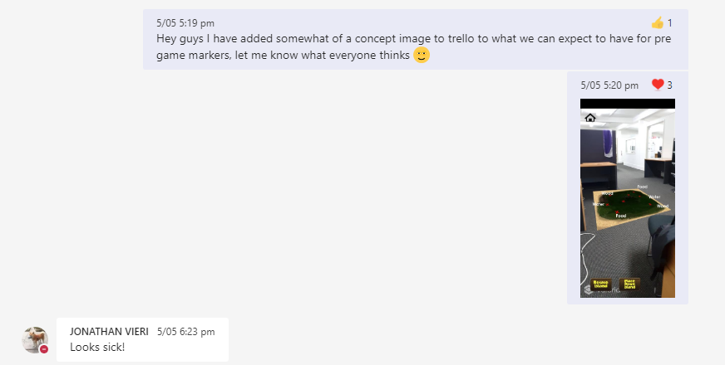

**Sourcetree Commits and Processes:**

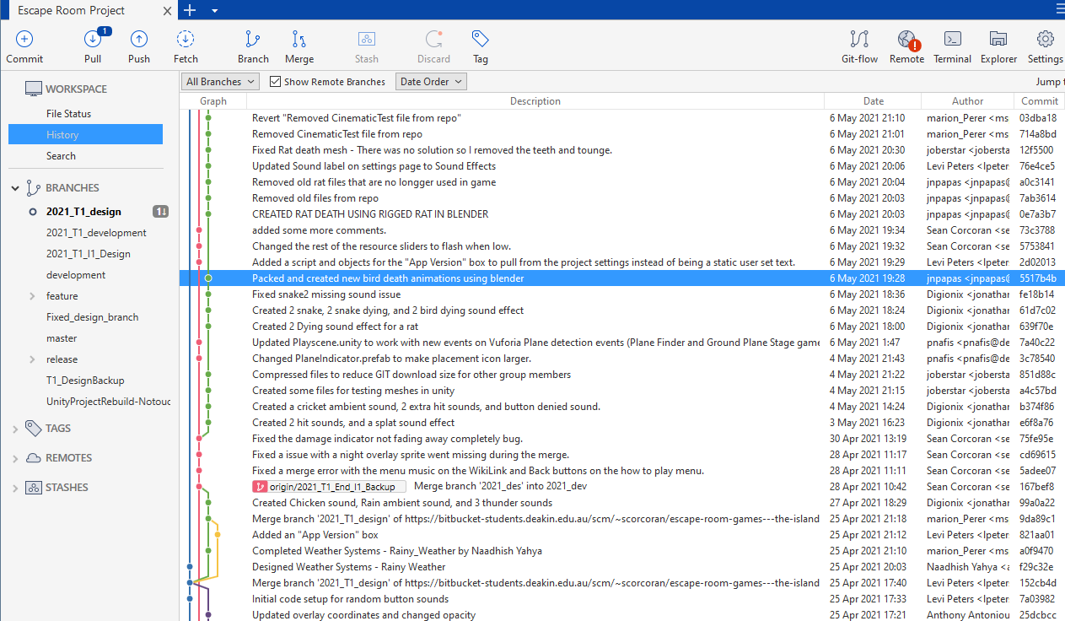

## My Completed Work:

Added Settings overlay to Play scene, and Pause Panel:

|  |  |
| --- | --- |
|  |  |

**Added Credits to Pause Panel:   
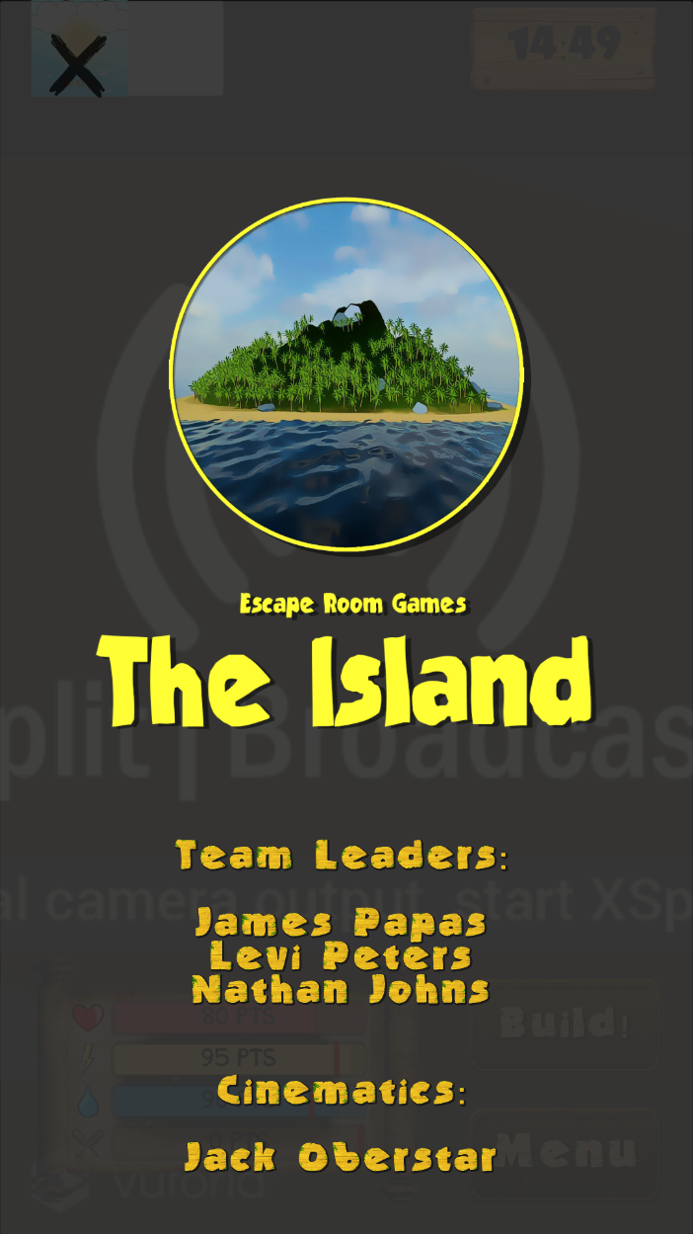**

**Import Animal Characters and Animations to Unity from Blender:**

* **High Difficulty**

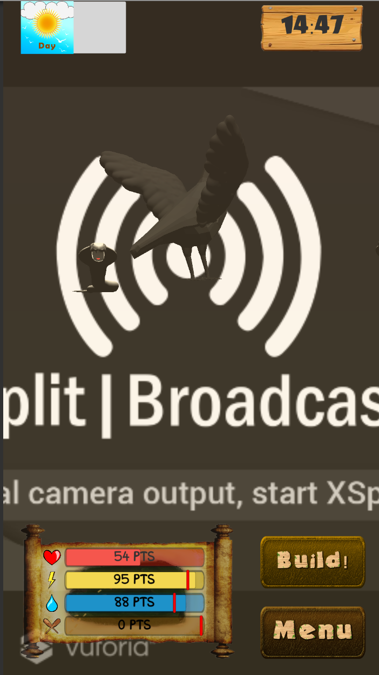

**Slowed Down Title to main menu Animation:**

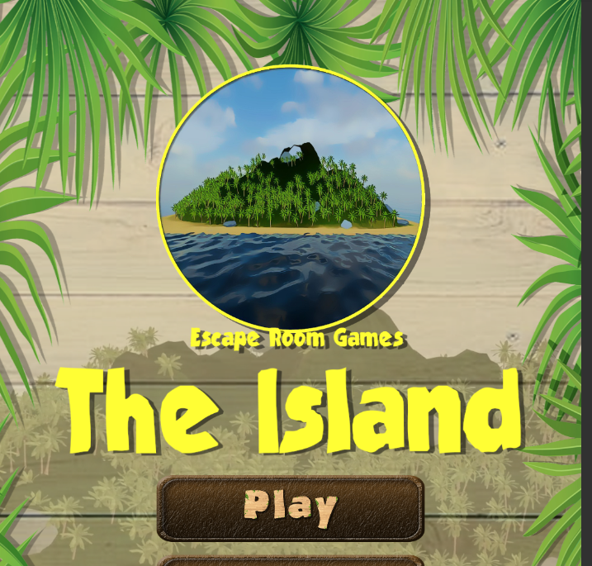

**Added new button text to buttons in play scene:**

|  |  |
| --- | --- |
|  |  |

**Redid Day & Night Graphics in photoshop:**

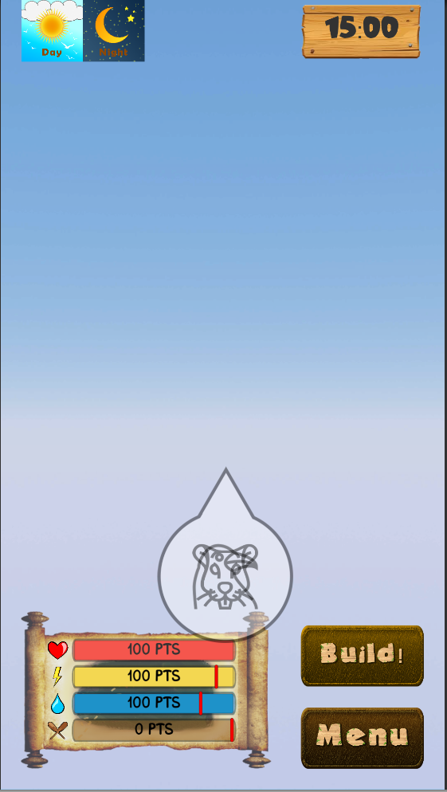

**Created Pre Game Marker for Implementation with Parisa:**

